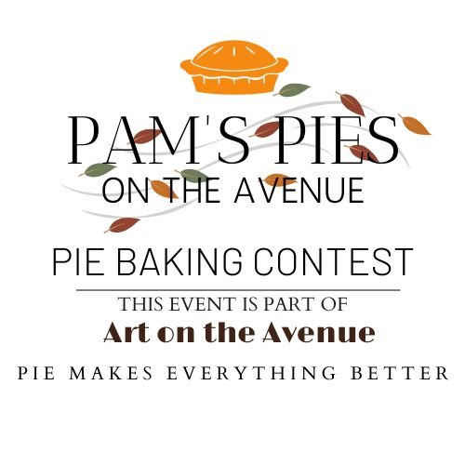
2023 Pie Contest
REGISTRATION FORM
REGISTRATION DEADLINE: Oct 7, 2023 at 11:45 am

Pies will be judged in 2 categories: Youth and Adult. See rules on the back of this document.
Pies will be judged at noon. Winner announcements and awards will be presented at ~1pm.

Please bring this form and your pie to the Pie Booth located in front of The Dog Store and across from St. Elmo’s Coffee Pub at Del Ray Avenue and Mt Vernon Ave on Oct 7 between 10:15am and 11:45am.

Pies will be judged based on Taste and Creativity.
Taste includes the balance of flavors and texture for both filling and crust.
Creativity includes the Pie Name and Appearance.
(See details below)

After judging is completed, all pie slices will be sold to raise funds for the Alexandria Domestic Violence Safehouse

Pie Name: _________________________________________

Pie Description: _________________________________________________________________________________________________________________________________________________________

Pie Judging Category: Youth (under 18) or Adult (18 and over)
(Circle one)

Baker’s Information
Name: __________________________________________ Age: ______
Contact Information (phone and email): ______________________________
__________________________________________________________

Judging Details

TASTE
- Is it pleasing to the taste buds?
- Does it make you want to eat more?
- Is there an appropriate balance of flavor?
- Is the texture appealing?

CREATIVITY
Appearance
- Is it pleasing to the eye?
- Does it look appetizing?
- Do you want to take a big bite out of it right now?

Name
- Did thought go into naming?
- Does it tie to pie flavors?
- Does it make you want to look at and taste this pie?
- Is it unique?
- Does it make you chuckle or smile?

~~~~~~~~~~~~~~~~~~~~~~~~~~~~~~~~~~~~~~~~~~~~~~~~~~~~~~~~~~~~

Pam’s Pie Contest Rules
• Adult entrees are created by individuals that are over 18 years old.
• Youth entries are created by individuals that are 18 or younger. Note: It is expected that younger entrants receive
“age-appropriate” supervision/assistance by an adult.
• All entries must be entered in the name of the person who created the pie.
• The Alexandria Health Department requires that, for health and safety reasons, pies that require refrigeration such
as custard, meringue, cream, pumpkin or sweet potato cannot be accepted.
• Pies must be baked in an 8–10inch pie pan. Disposable pans are recommended. If a reusable pan is used, please
pick it up at the Festival Store after the contest. Do not use a valuable or sentimental pan.
• Pies must be brought to the Pie Contest Tent between 10am and 11:45am on October 7th. Late entries might not be
accepted so please note the 11:45 sharp deadline. The Pie Contest Tent will be located across from the Festival Store
on Mt. Vernon Avenue between Del Ray and Oxford Avenues.
• There is no fee to enter the contest.
• Each pie must be accompanied by an entry form.
• Contestants can enter as many pies as they wish with a separate entry form with each pie.
• All pies will become the property of Art on the Avenue with all proceeds from sales going to a local non-profit.
• Judging will begin at noon.
• Winners will be announced following judging at approximately 1:00 pm.
• Winners will also be invited on stage at 2:00pm to be presented with their prize. Prizes are
awarded to the 1st place winner in each category

